

**Team Member 1 - Sameer Rudani**

**Team Member 2 - Manasvi Save**

**Cohort Name - Cohort Santiago**

**Product Dissection for Zomato**

# **Company Overview:**

Zomato is an Indian multinational food delivery and restaurant aggregation firm based in India that has operations in several nations. With its headquarters located in Gurugram, Haryana, India, the company was started in 2008 by Deepinder Goyal and Pankaj Chaddah. It began as a platform to assist users in finding restaurants and in reading and writing reviews of them.

Here is an overview of Zomato's various services and its evolution:

Restaurant Discovery

Food Delivery

Zomato Gold

Table Reservations

Online Ordering

Zomato Pro

International Expansion

# **Product Dissection and Real-World Problems Solved by Zomato**

Using the user-friendly Zomato app and website users may search for restaurants, browse menus, and place meal orders. Zomato maintains a comprehensive database of restaurants, complete with menus, locations, phone numbers, and user-generated reviews and ratings. To efficiently facilitate food deliveries, Zomato oversees a network of delivery partners. Because the platform integrates with multiple payment methods, users can complete transactions with greater ease. Users have the ability to help others make informed decisions by reviewing and rating restaurants.

**Real-World Problems Solved by Zomato**

**Restaurant Discovery:** Zomato assists users in learning about new eateries and cuisines nearby or abroad.

**Online Food Ordering:** A variety of restaurants are available for users to place online food orders from Zomato. Those who wish to enjoy restaurant-caliber cuisine at home without physically visiting the restaurant will find this to be of particular use.

**User Reviews and Ratings:** This helps people make informed decisions about where to eat and what to order, reducing the risk of having a bad dining experience.

**Menu Information:** Zomato offers comprehensive details on restaurant menus, encompassing costs, featured dishes, and nutritional facts.

**Table Reservations:** Zomato has a feature that lets users reserve tables at restaurants ahead of time.

**Online Payment and Delivery Tracking:** Zomato makes ordering meals easy and transparent for customers by providing real-time order tracking and online payment options.

**Minimising Food Waste:** Zomato launched the "Feeding India" initiative, which assists in distributing leftover food from eateries to those in need, thereby mitigating food waste and tackling the problem of hunger.

In conclusion, Zomato's product design has effectively addressed a variety of real-world issues facing the food and restaurant industry by embracing technology and data, making it easier for customers to find, buy, and enjoy food while also assisting restaurants in growing their customers.

# **Case Study: Real-World Problems and Instagram's Innovative Solutions**

Zomato, leading and food delivery platform in India it has expanded globally, becoming one of the world's leading food delivery and restaurant discovery platforms. Foodies and those wishing to try new restaurants or place delivery orders for food have come to rely on the company's website and mobile app. Zomato's popularity is due to its easy-to-use interface, a comprehensive directory of restaurants, and its capacity to link users with nearby dining options and delivery services.

## **Problem 1: Insufficient Restaurant Visibility**

**Real-World Challenge:** Prior to the existence of websites like Zomato, local eateries frequently had visibility issues. They discovered that it was difficult to compete with well-known chains and reach a wider audience.

**Zomato's Solution:**

Zomato compiled a huge database of restaurants, including eateries in the area. Even the smallest eateries were able to display their menus, costs, and reviews on their platform. Local businesses gained more exposure as a result, which helped them draw in more customers.

## **Problem 2: Efficient Food Delivery**

**Real-World Challenge:** There were issues with timeliness, accuracy, and efficiency in food delivery. Regardless of the distance, customers expected their orders to be delivered hot and fresh.

**Zomato's Solution:**

Real-time tracking and route optimization algorithms are two of the cutting-edge delivery solutions that Zomato introduced. This improved customer satisfaction by guaranteeing on-time deliveries. Furthermore, Zomato collaborated with eateries to preserve food quality while it was in transit, ensuring that patrons had a better dining experience.

## **Problem 3: User Experience and Personalization**

**Real-World Challenge:** Users frequently found it challenging to choose the ideal restaurant or cuisine because there were so many options available. Customers also wanted recommendations that were tailored to them according to their preferences.

**Zomato's Solution:**

To examine user behavior and preferences, Zomato used machine learning algorithms and data analytics. They put in place a customized recommendation system that makes restaurant and food recommendations based on user preferences. This enhanced the user experience by making it simpler for patrons to find intriguing new dining options.

## **Problem 4: Safety and Hygiene Concerns**

**Real-World Challenge:** Particularly following the COVID-19 pandemic, patrons' concerns regarding the hygienic practices and safety standards adhered to by eateries and food delivery services grew.

**Zomato's Solution:**

Zomato put strict safety regulations in place for eateries and delivery partners. In order to ensure that there was little physical contact during delivery, they introduced contactless delivery options. In order to reassure customers about the quality and safety of their orders, Zomato also permitted restaurants to prominently display their hygiene and safety protocols on the platform.

## **Conclusion:**

Zomato's creative solutions have changed consumers' perceptions of and experiences with food services in addition to addressing a number of issues facing the food industry. With an emphasis on improving the user experience, helping out small businesses, and putting efficiency and safety first, Zomato has emerged as a major force in the global food delivery and restaurant search markets.

# **Top features of Zomato**

Zomato provided a number of tools to improve customer experience and expedite ordering and dining at restaurants. Here are some of the most popular features that were prevalent on the Zomato platform at the time, however some may have been altered or added since then:

**1. Restaurant Discovery:**

* Search and Filters: Users could search for restaurants based on cuisine, location, cost, and user reviews. Filters allowed users to narrow down options according to their preferences.
* User Reviews and Ratings: Zomato allowed users to read and write reviews, helping others make informed decisions about where to eat.

**2. Menu and Price Listings:**

* Online Menus: Users could view the complete menu of restaurants, including dish details, prices, and images.
* Price Range: Zomato provided a price range indicator for each restaurant, allowing users to find options within their budget.

**3. Online Ordering:**

* Order Placement: Users could place food orders directly through the Zomato app or website, selecting dishes from the restaurant's menu.
* Delivery Tracking: Zomato offered real-time order tracking, enabling customers to monitor the status and location of their food delivery.

**4. Table Reservations:**

* Table Booking: Zomato allowed users to reserve tables at restaurants, ensuring they had a spot without waiting in queues.
* Special Offers: Users could access exclusive deals and discounts when booking through Zomato.

**5. User Engagement:**

* Zomato Gold: Zomato Gold was a subscription-based service that offered complimentary food and drinks at partner restaurants during certain hours. Users could enjoy special privileges as Gold members.
* Collections: Zomato curated lists of restaurants based on themes such as romantic dining, family-friendly places, or trending eateries.

# **Schema Description:**

The schema for Zomato involves multiple entities that represent different aspects of the platform. These entities include Users, Restaurants, Menu, Orders, Drivers, Payments, Ratings, and more. Each entity has specific attributes that describe its properties and relationships with other entities.

**User Entity:**

A user can place one order at a time, and each order is associated with one user. The user entity contains information about each user:

**UserID (Primary Key):** A unique identifier for each user.

**Username:** The chosen username for the user's account.

**Email:** The user's email address for account-related communication.

**Password:** Encrypted user password for account security.

**Phone:** Contact number for SMS notifications or verification.

**Restaurant Entity:**

The restaurant entity helps users search for and choose restaurants based on their preferences.

**RestaurantID (Primary Key):** A unique identifier for each user.

**Name:** The name of the restaurant.

**Location:** The physical address of the restaurant, including city, state, and postal code.

**Phone:** Contact number for SMS notifications

**Order Entity:**

The orders entity typically represents a collection of information and data related to the orders placed by customers.

**OrderID** **(Primary Key):** A unique identifier for each order.

**UserID:** The ID of the user placing the order.

**RestaurantID:** The ID of the restaurant from which the order is placed.

**Order_Total:** The total cost of the order.

**Delivery_Status:** The name of the delivery person, estimated delivery time, and a tracking link.

**DriverID:** The ID of the delivery person

**Driver Entity:**

The drivers entity typically refers to the individuals who work as delivery drivers for the platform. These drivers are responsible for picking up food orders from restaurants and delivering them to customers locations.

**DriverID (Primary Key):** A unique identifier for the driver.

**Name:** The driver's full name.

**Phone:** Phone number of driver.

**Location:** The driver's real-time location, which is typically updated using GPS.

**Email:** Email address of driver.

**Payment Entity:**

The payments entity helps to facilitate transactions between users and restaurants.

**PaymentID (Primary Key):** Reference number or code that helps the app and the payment gateway identify and process your payment.

**OrderID:** The Order ID is essential for tracking your order, as it is linked to your specific order details.

**Payment_Method:** Zomato allows users to link various payment methods to their accounts, including credit/debit cards, digital wallets (e.g., Paytm, Google Pay).

**Amount:** The amount entity that can store and manage monetary amounts.

**Status:** Status of a payment transaction made by a user for a food order.

**Rating entity:**

The rating entity in the Zomato app is used to store and manage user ratings for restaurants.

**RatingID:** Identifies a specific user's rating for a particular restaurant.

**UserID:** Generally kept confidential to protect user privacy.

**RestaurantID:** The restaurant ID might be included in the URL

**Rating:** Refers to the numerical score given by users to express their satisfaction with a particular restaurant or food establishment.

**Relationships are:**

**User chooses Restaurant :** User can choose from multiple restuarants.

**Restaurant has Orders :** Restaurant can have multiple orders.

**Order has Payment :** Each order has an individual payment.

**Driver has Orders:** Driver has multiple orders.

**User makes Payment :** Users can make payments on Zomato through various methods such as credit/debit card, UPI, mobile wallet.

**User gives Ratings:** User can rate based on their dining or delivery experience at a restaurant or food establishment.

**ER Diagram:**

By highlighting the tables, their characteristics, and the connections between them, ER diagrams can assist in organising the database's layout and streamlining the database design process.Drawing an ER diagram compels you to list the entities and their characteristics, which aids in developing a thorough grasp of the system and the data needed for it.ER diagrams show how various entities are related to one another. This can include, among other things, relationships between users and restaurants, orders and restaurants, and user reviews on Zomato. Understanding the system's data flow is made easier with the help of this visualisation.

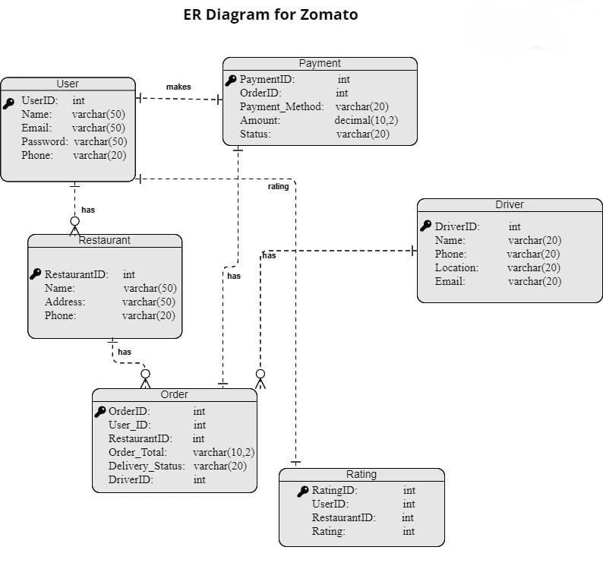

# **Conclusion**

In this case study, we delved into the design of Zomato's schema and Entity-Relationship diagram. Zomato has indeed revolutionized the way people discover and order food. The platform's intricate data model, consists of entities like Users, Restaurants, Menu, Orders, Drivers, Payments, Ratings. Zomato has revolutionized the food industry by leveraging technology to make food discovery, ordering, and delivery more convenient, accessible, and transparent. It has transformed the way people experience dining and has also provided support to the restaurant industry by increasing its reach and business opportunities.